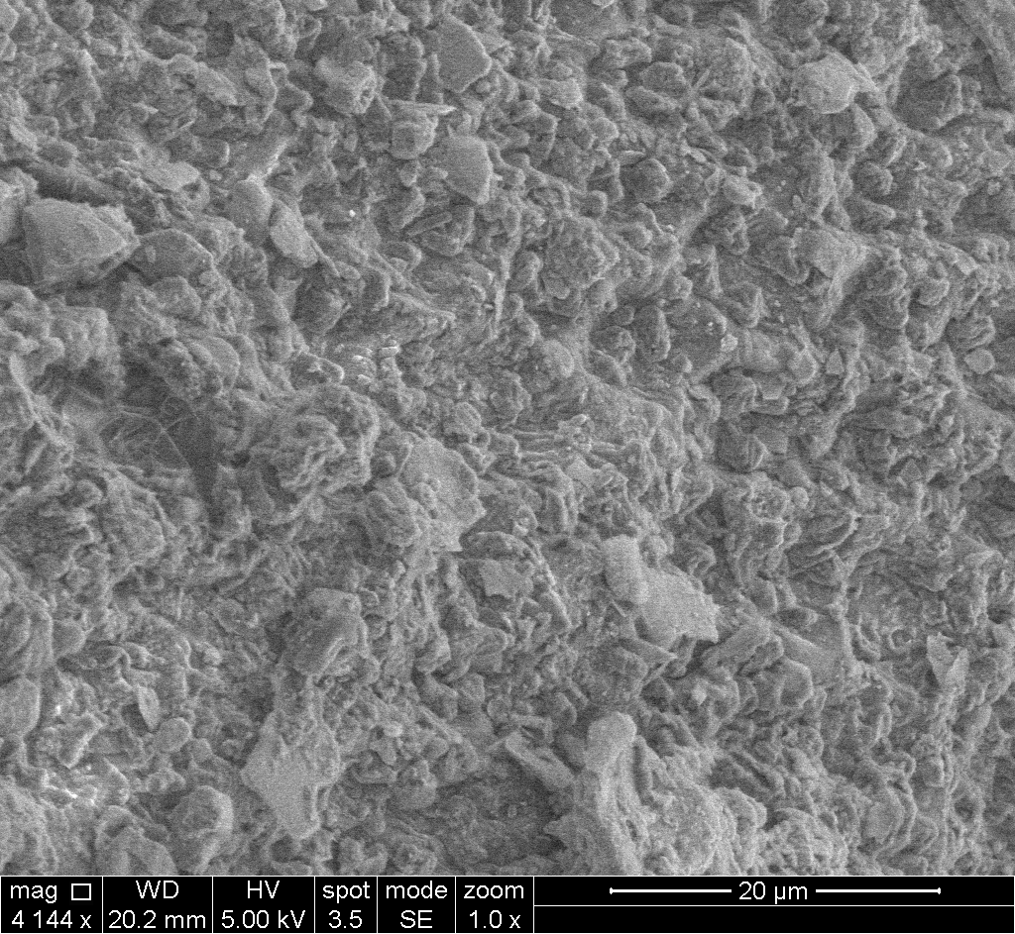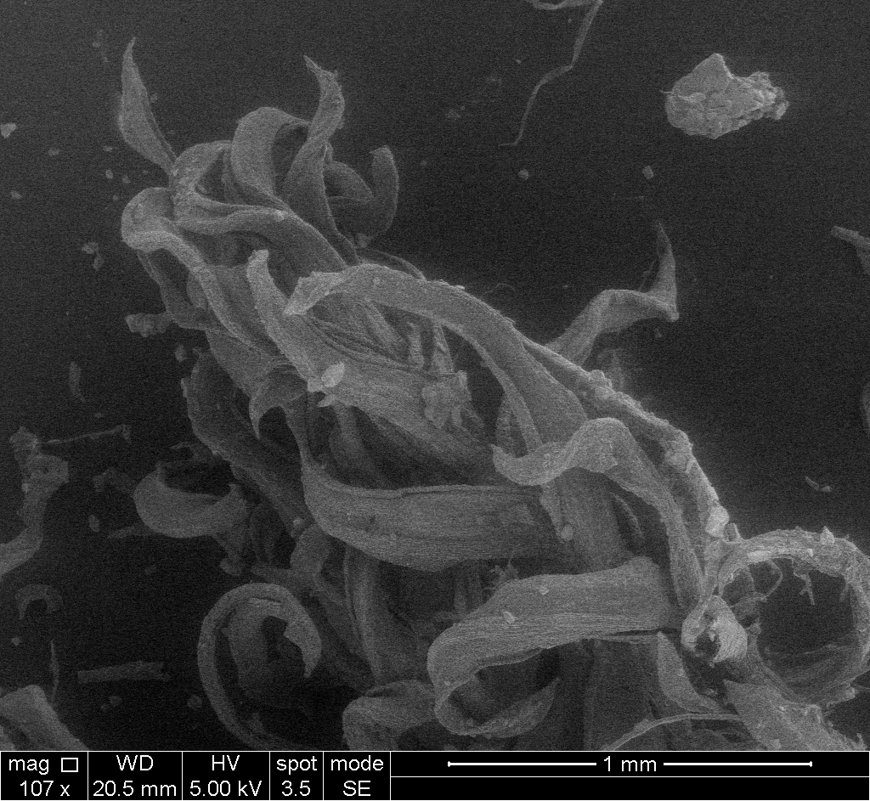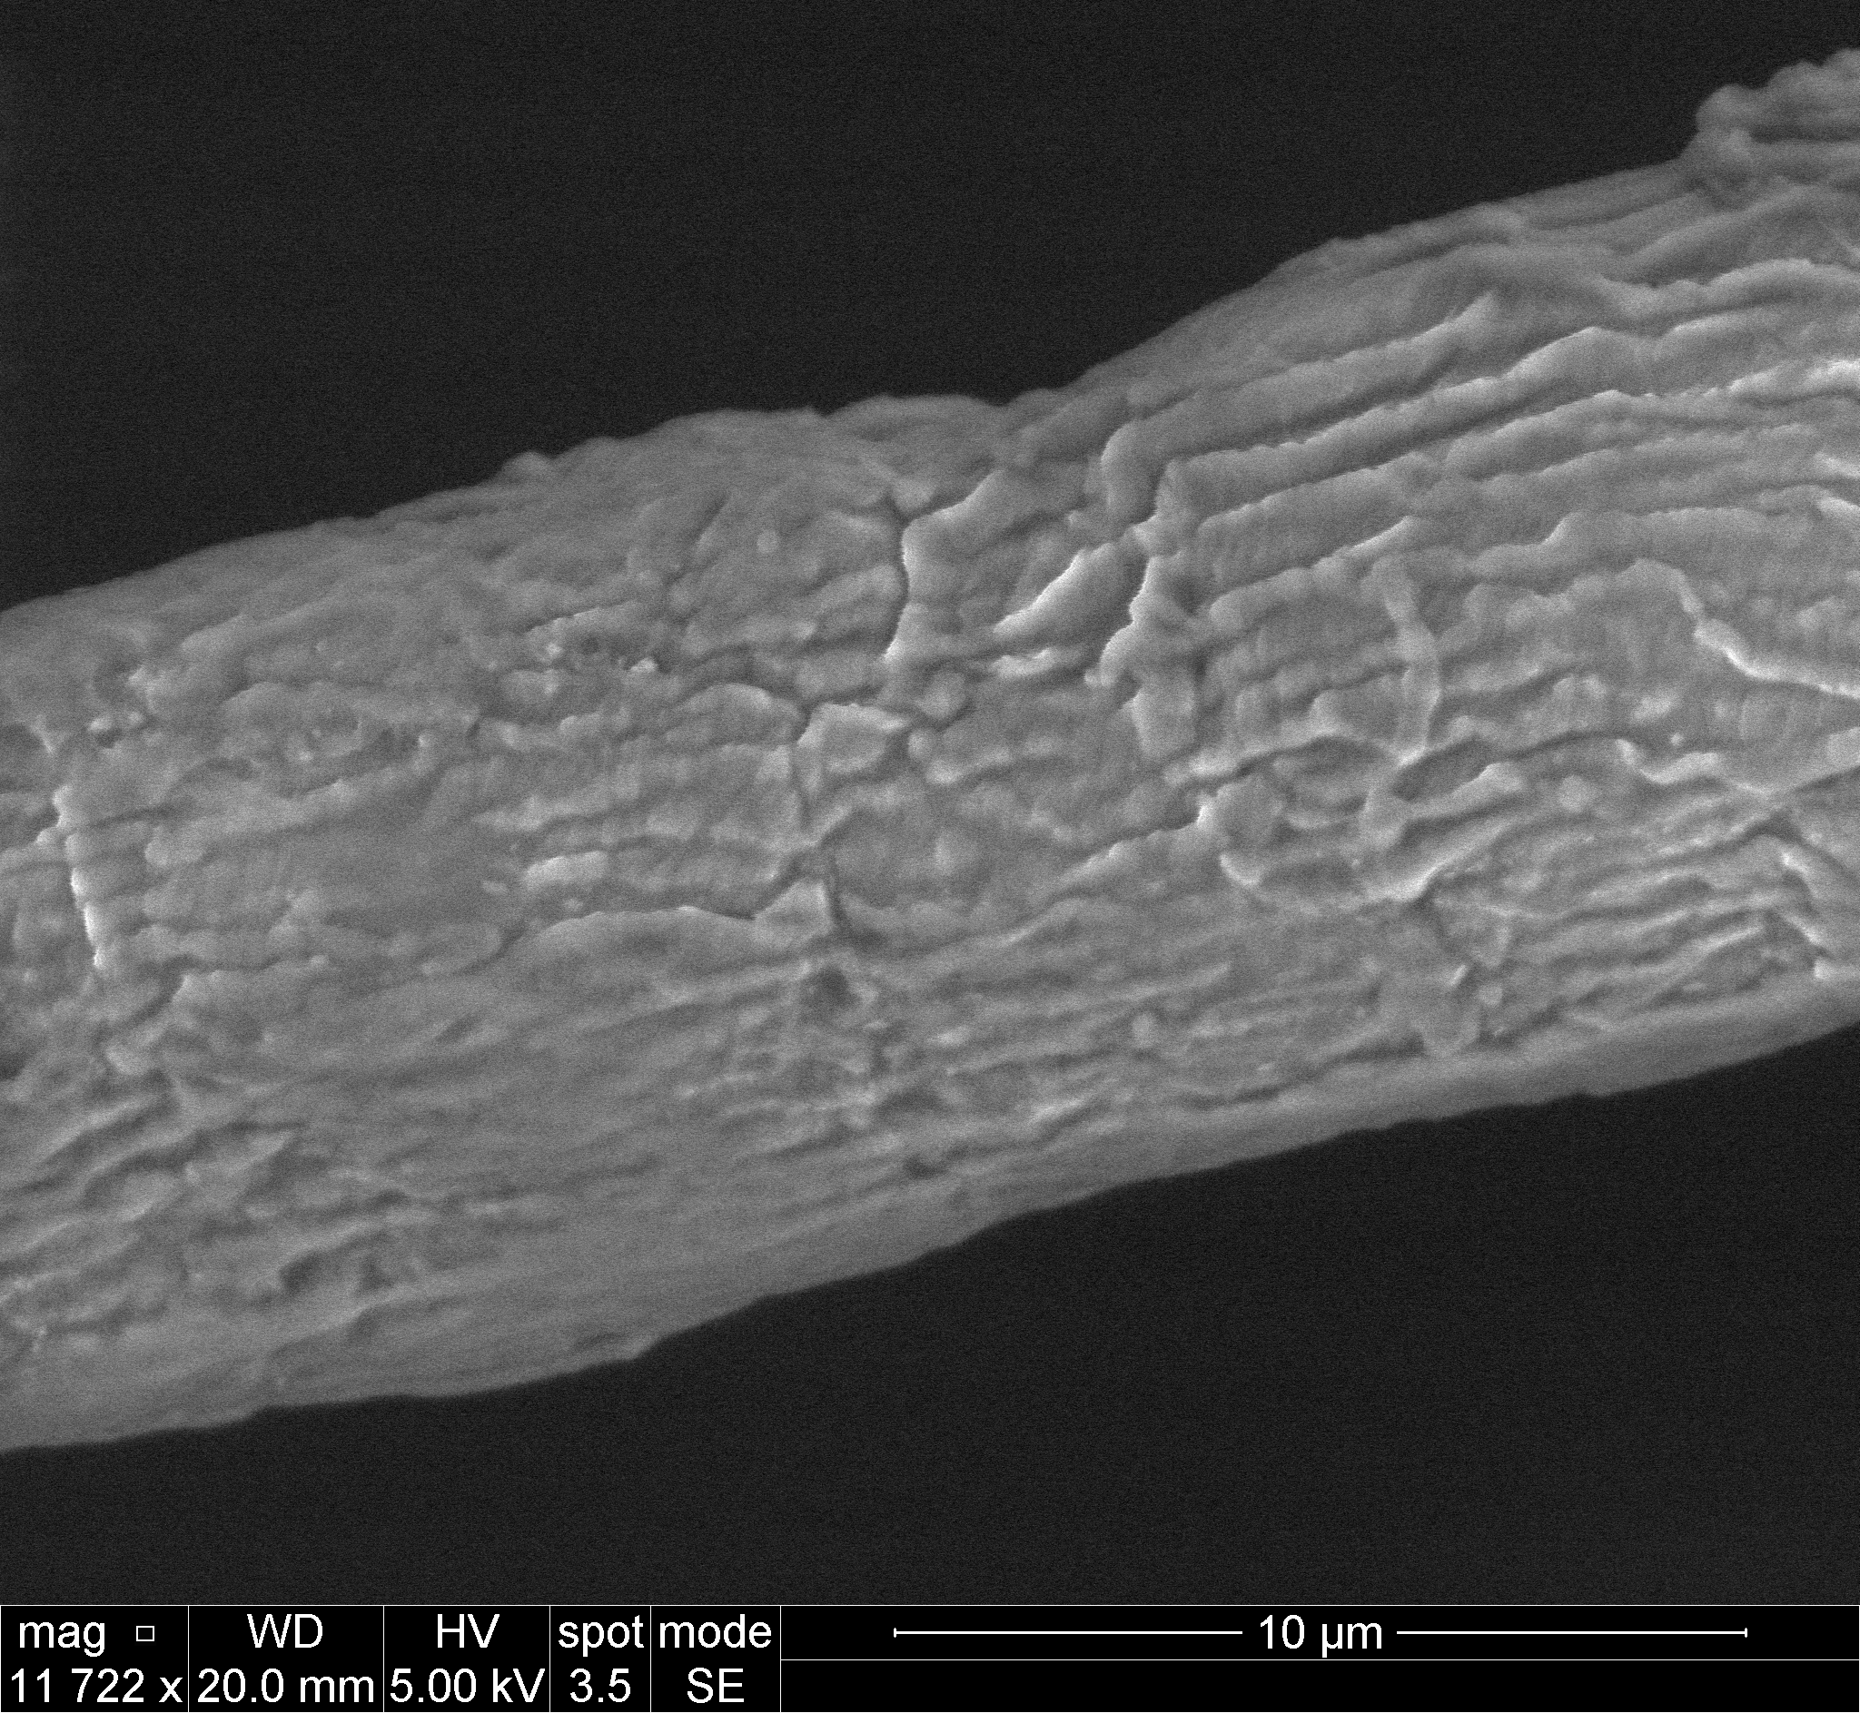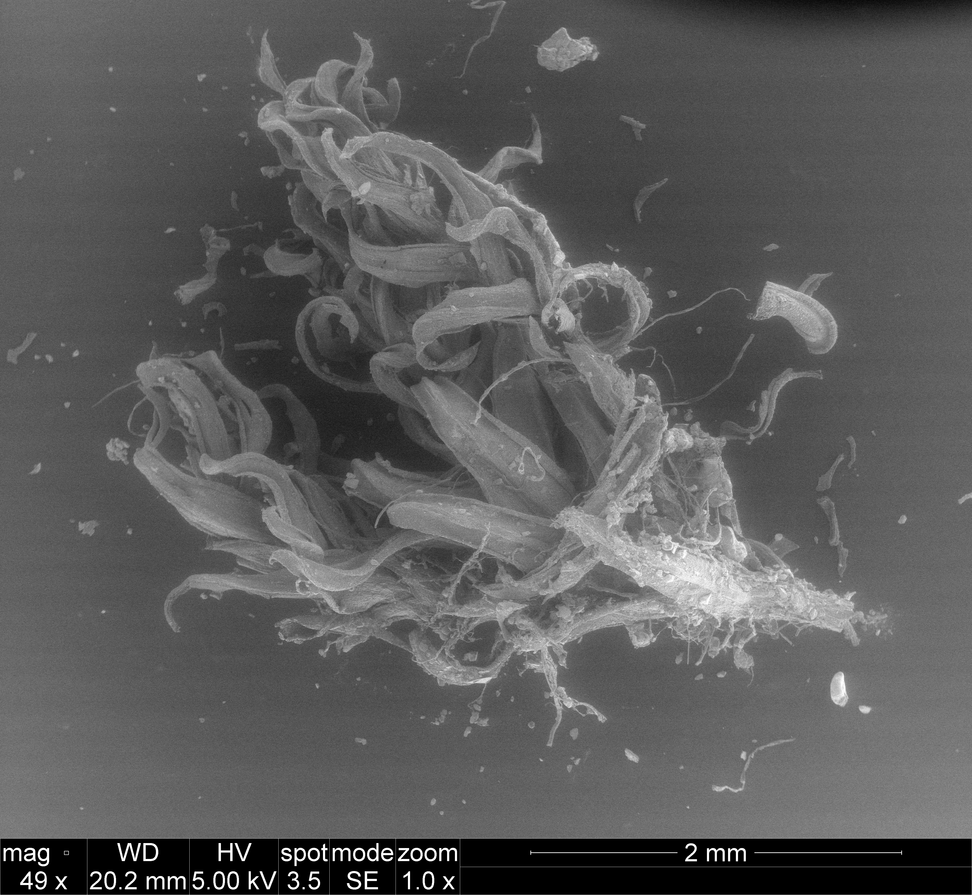

Microscopic Moss

These are microscopic images taken of moss using the FEI Quanta 600 FEG Mark II Environmental Scanning Electron Microscope.

This moss was gathered in northern Philadelphia, Pennsylvania, USA on Tues. May 20, 2025.

The next day, Wed. May 21, the moss was briefly frozen with liquid nitrogen (LN2) before being left to outgas under vacuum for an hour or two, in order to ensure that it was dry.